**Shehan’s Project Diary**

Firstly, I didn’t remember some HTML Parts and I didn’t know some JSP and Servlet Parts. So, my first task is remembering knowledge that I had forget and learn more about java Servlet and JSP Pages. My Final Challenge was I didn’t know how to upload my part to the GitHub repository. At that time, we were on vacation, so we couldn't discuss that. After we came to the university, we discussed this, created a repository, collaborated with members, and started uploading our project files.

**Week 1 (April 17 - April 21, 2024)**

April 17, 2024 (Wednesday)

* Remembered the HTML, CSS and Java Script

April 18, 2024 (Thursday)

* Studied about JSP Pages

April 19, 2024 (Friday)

* Studied about Java Servlets

April 20, 2024 (Saturday)

* Initiated Development on customer login feature.
* Create customer-login.jsp page to design the Login page interface.

April 21, 2024 (Sunday)

* Designed and customized the Login page interface.

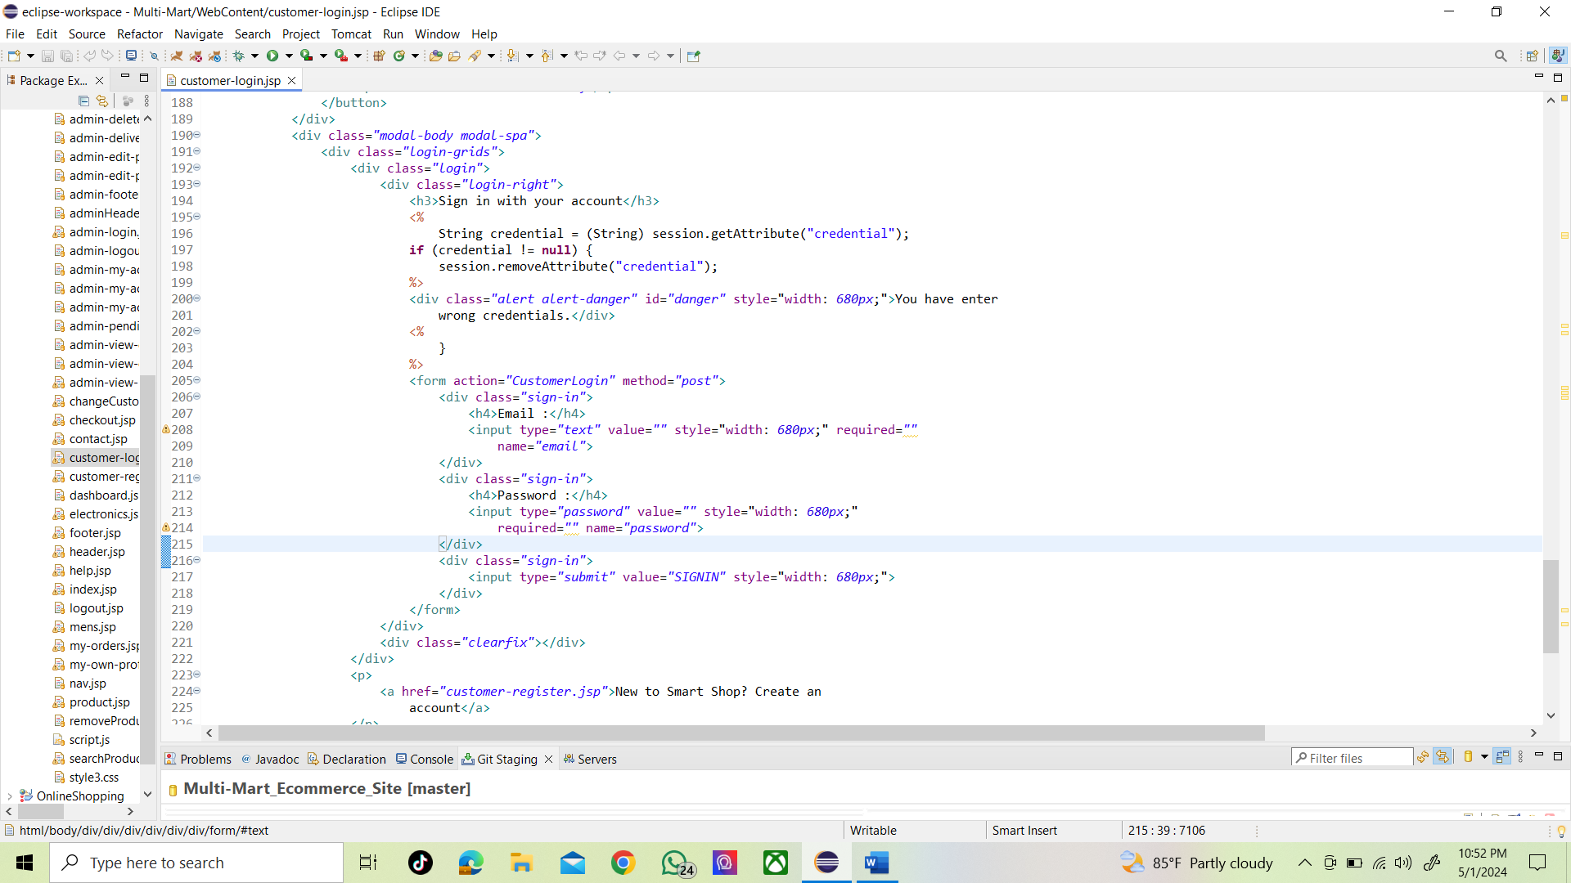

**Week 2 (April 22 - April 29, 2024)**

April 22, 2024 (Monday)

* Created customer-register.jsp page
* Created changeCustomerPassword.jsp Page

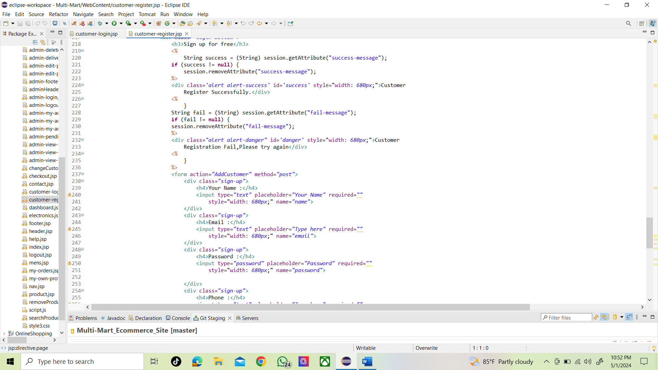

April 23, 2024 (Tuesday)

* Created my-orders.jsp page
* Created my-own-profile.jsp page

April 24, 2024 (Wednesday)

* Created logout.jsp page
* Created products.jsp page

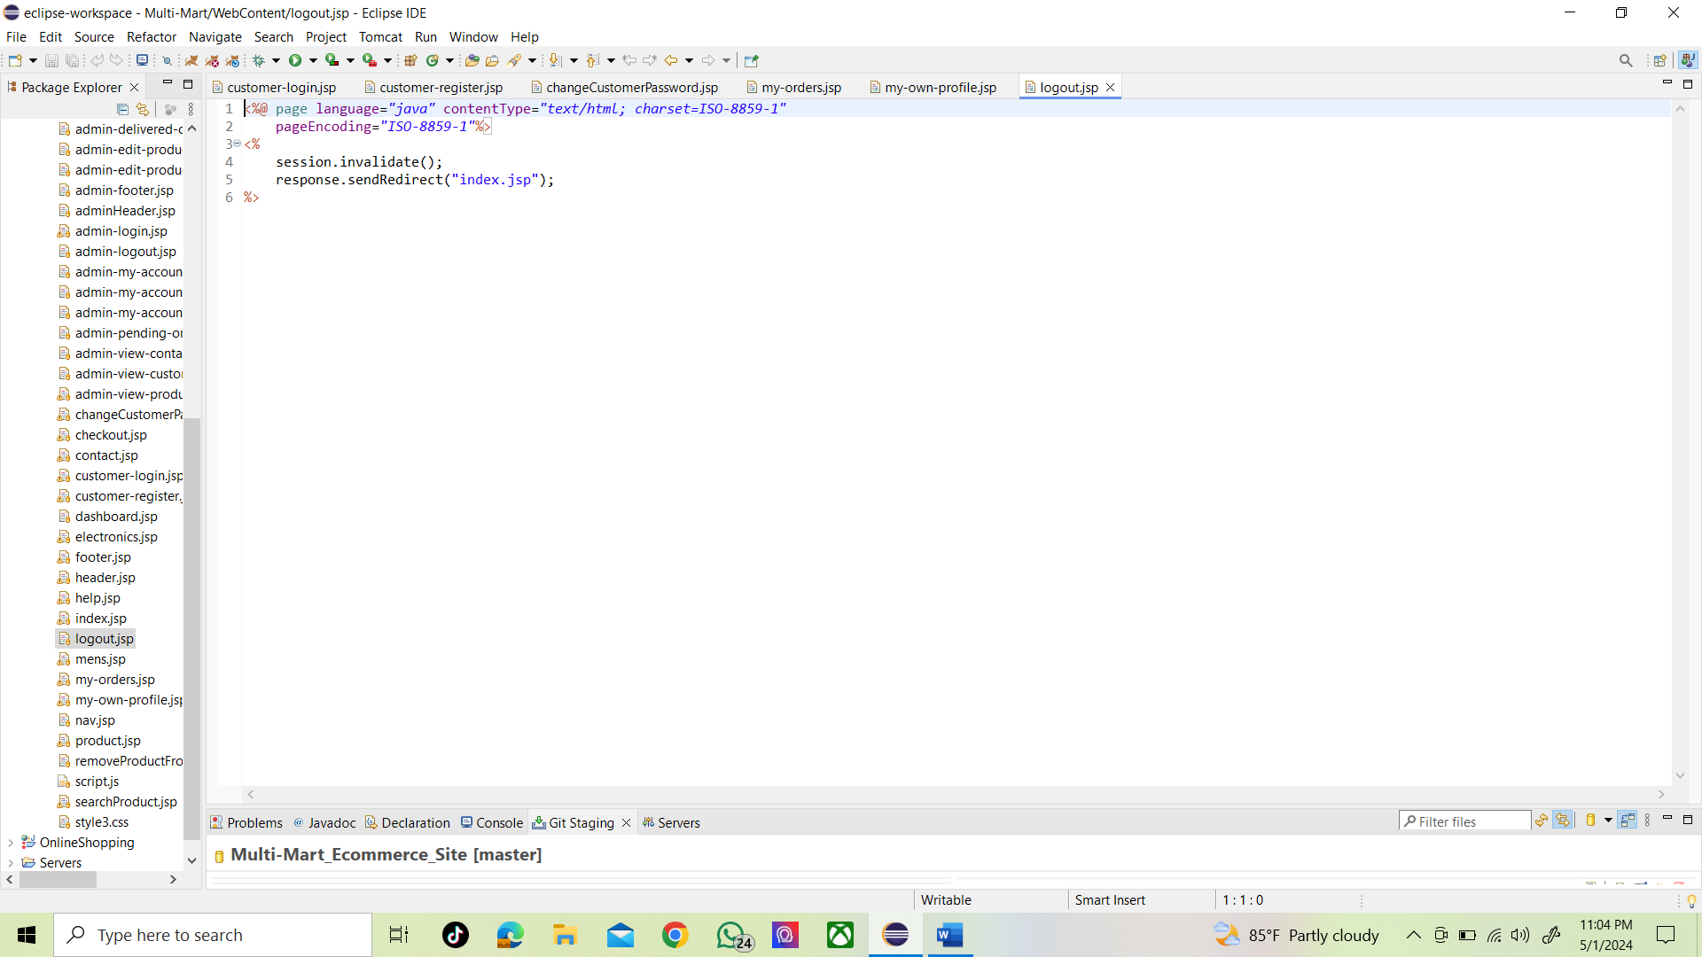

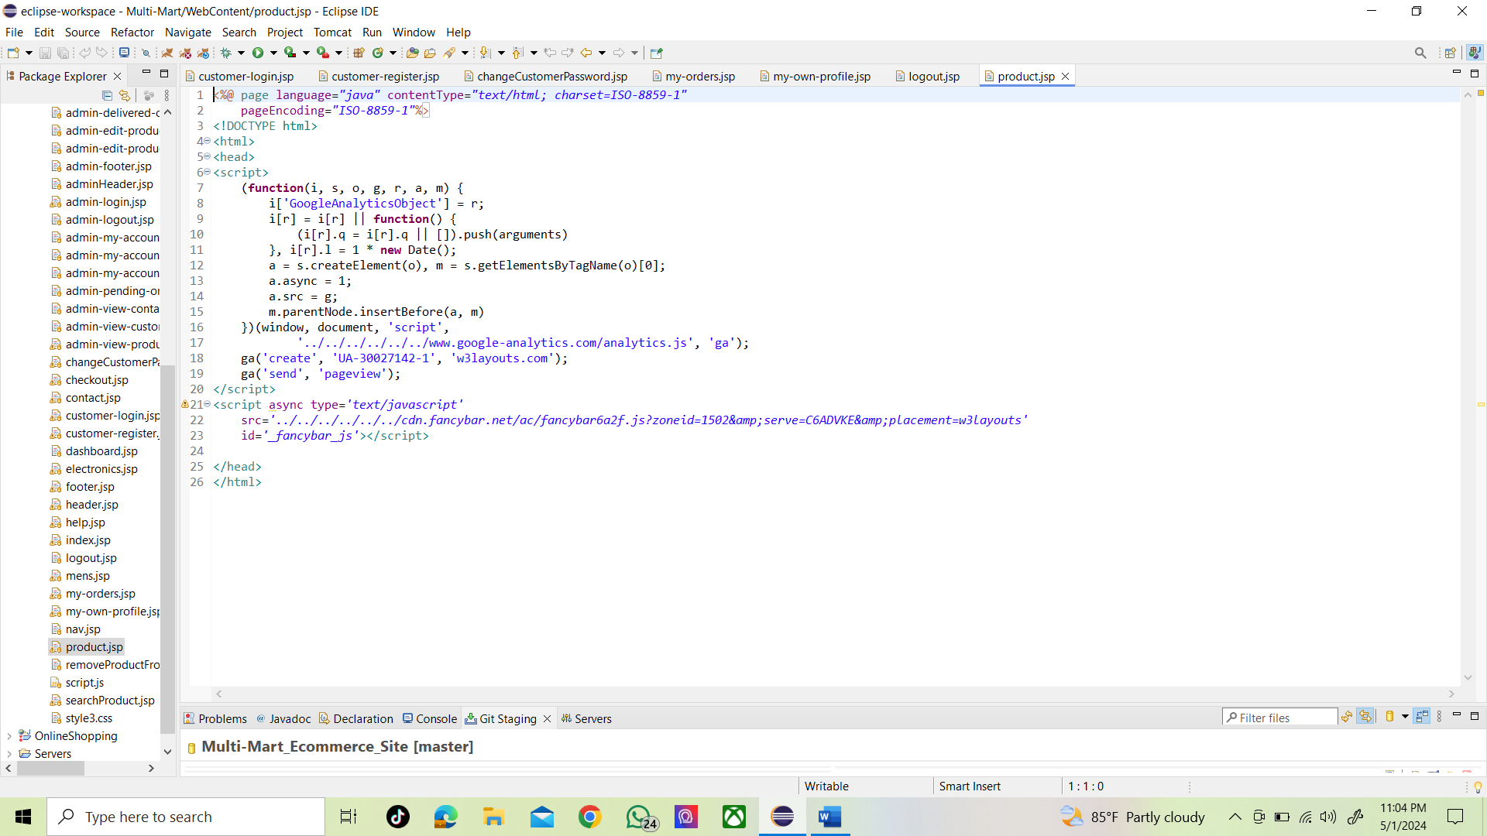

April 25, 2024 (Thursday)

* Created CustomerLogin.java Page

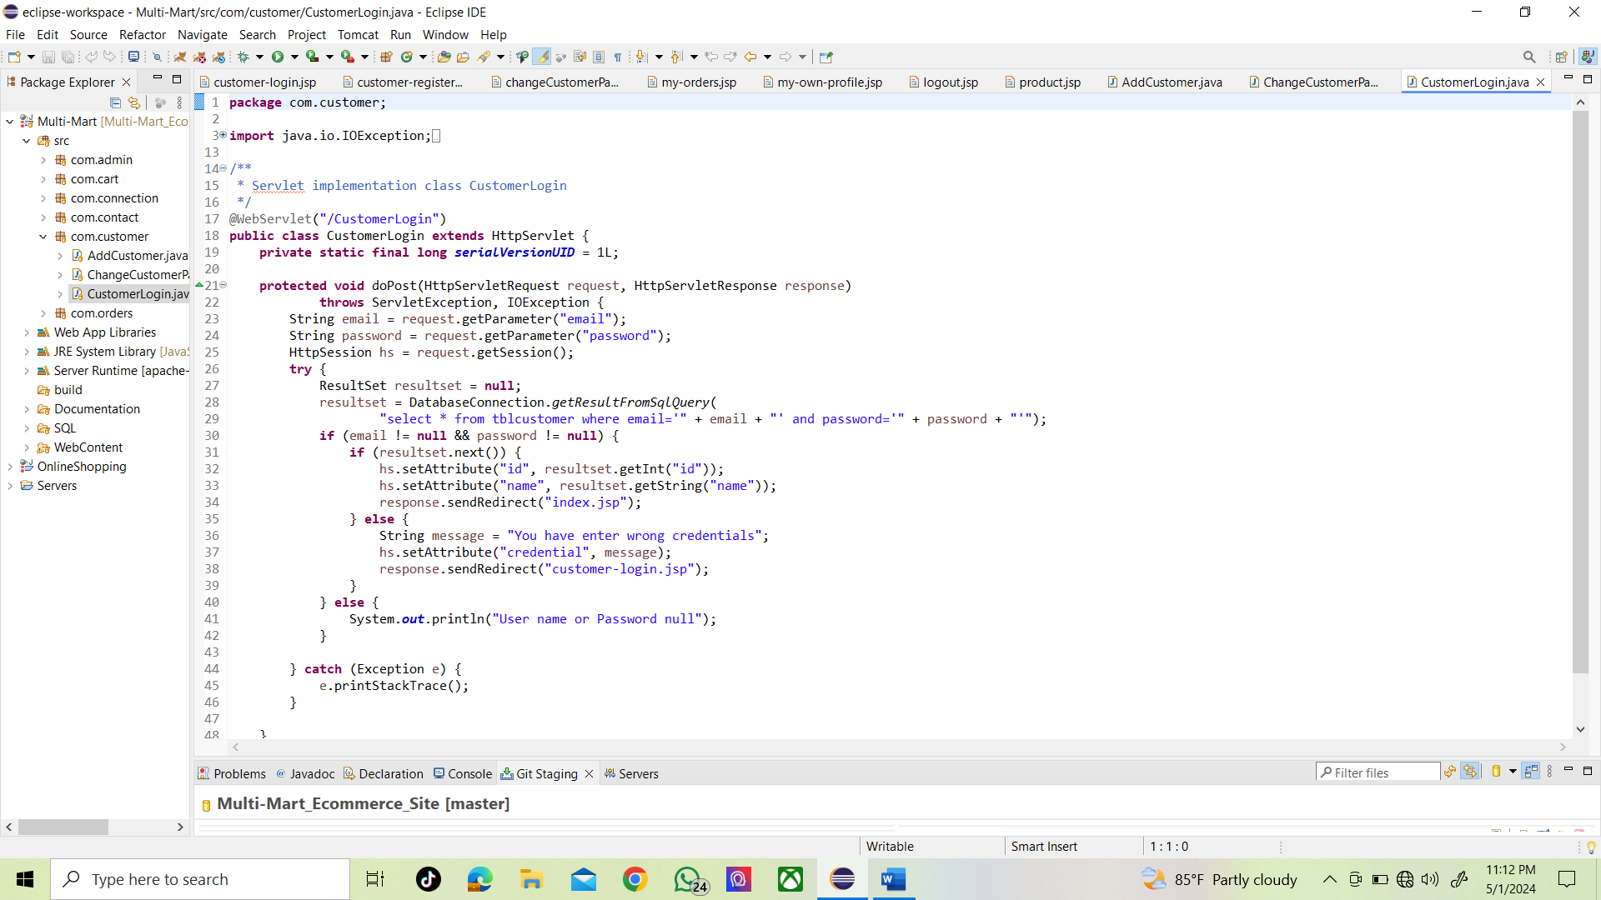

April 26, 2024 (Friday)

* Created ChangeCustomerPassword.java page

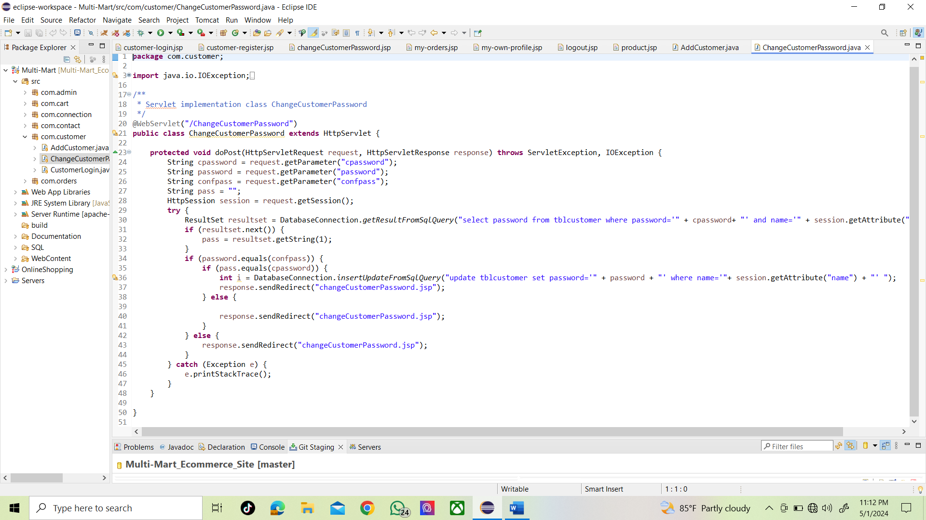

April 27, 2024 (Saturday)

* Created AddCustomer.java page

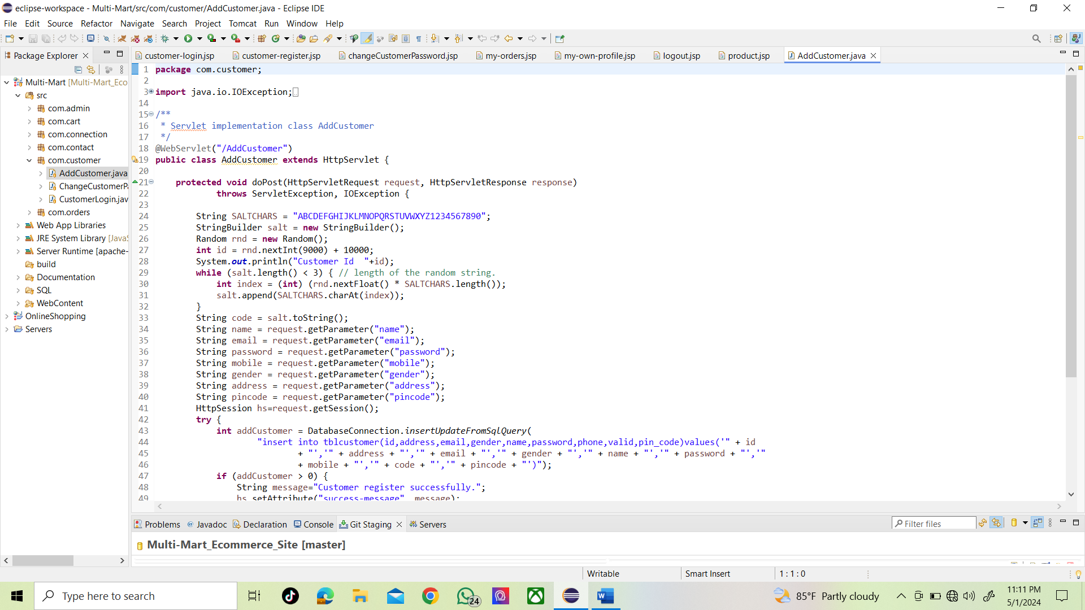

April 28, 2024 (Sunday)

* Learn How to push the GitHub.
* Pushed the customer – login.jsp page and customer – register.jsp pages

April 29, 2024 (Monday)

* There was an error in the GitHub pushing and we searched for the solution for that error.
* We could resolve the error.

May 1, 2024 (Wednesday)

* Pushed the CustomerLogin.java page , AddCustomer.java page and the ChangeCustomerPassword.java page , my-own-profile.jsp page , products.jsp page,changeCustomerPassword.jsp page
* Edit logout.jsp page

**Challenges that Faced**

The main Challenge that we met was the GitHub Pushing. We use the software called GitCMD to push the GitHub. When we push through that software, again and again we had rejected error. So, we had to search how to resolve that error. That the main challenge that I faced. Another challenge is difficult JS functions that I should use.